**Project Design Phase-II**

**Data Flow Diagram & User Stories**

|  |  |
| --- | --- |
| Date | 03 October 2023 |
| Team ID | NM2023TMID08200 |
| Project Name | iRevolution: A Data-driven Exploration of Apple's iPhone Impact in India |
| Maximum Marks | 4 Marks |

**Data Flow Diagrams:**

A Data Flow Diagram (DFD) is a traditional visual representation of the information flows within a system. A neat and clear DFD can depict the right amount of the system requirement graphically. It shows how data enters and leaves the system, what changes the information, and where data is stored.

Example: DFD Level 0 (Industry Standard)

**Example:** [**(Simplified)**](https://developer.ibm.com/patterns/visualize-unstructured-text/)

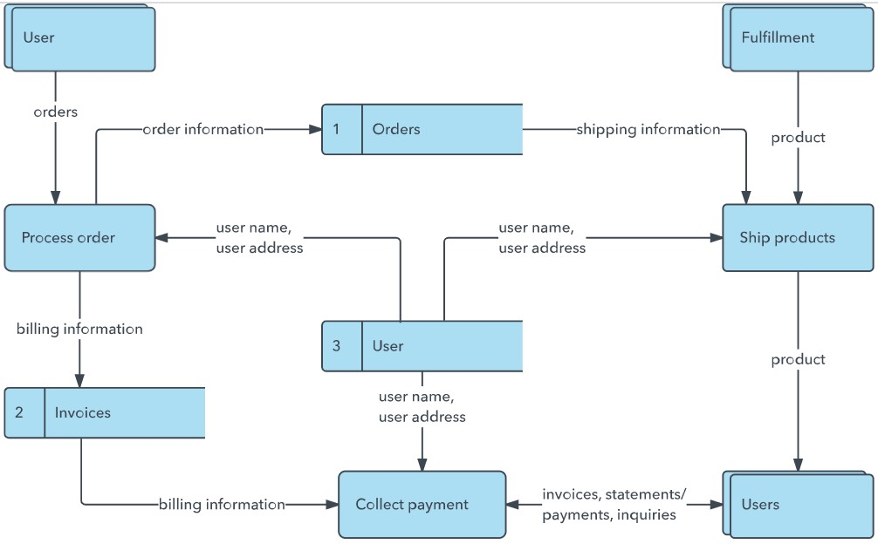

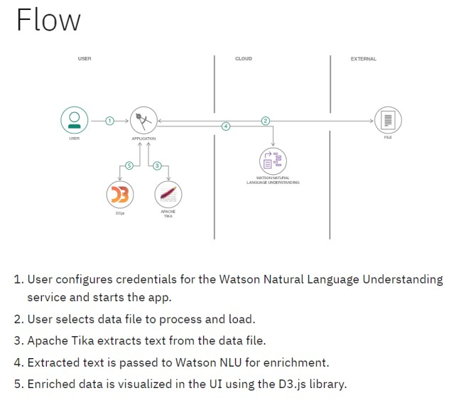

**User Stories**

Use the below template to list all the user stories for the product.

**User Stories**

|  |  |  |  |  |  |
| --- | --- | --- | --- | --- | --- |
| **User Type** | **Functional Requirement**  **(Epic)** | **Task** | **Acceptance criteria** | **Priority** | **Team Member** |
| Customer (Web user) | Registration | As a user, I can register for the application by entering my email, password, and confirming my  password. | I can access my account / dashboard | High | Vamsi |
|  |  | As a user, I will receive confirmation email once I have  registered for the application | I can receive confirmation email  & click confirm | Low | Anvesh |
|  |  | As a user, I can register for the application through Google | I can register & access the dashboard with Google Login | High | Venkata Sai |
|  |  | As a user, I can register for the application through Gmail |  | Medium | Ravi kanth |
|  | Login | As a user, I can log into the application by entering email & password |  | High | Venkata Sai |
|  | Dashboard | All the operation which the portal can perform | Once login Customer can view  dashboard |  |  |
| Customer (Web user) | Login & Dashboard |  |  |  |  |
| Customer Care  Executive | View number in dashboard | By sending the query or problem through mail agent we send a  reply |  | medium | Anvesh |
| Administrator |  | Agent from the team will perform the administrative duties |  |  |  |